RESISTANCE AND INDUCTANCE CALCULATOR

***Introduction:***

The value of the resistor is marked on the body using colors. Every color is different number and you can remember these numbers or you can just use the table on next step. But someone who is not familiar with this method or someone has not this color code chart and we do not hold this chart everywhere so it’s difficult to find the value of resistor. However it's your decision and I will show you all ways to calculate resistor value. Here we have make a project with the help of this we find value of resistance only seeing the color given on this and find accurate value of resistance. By this project no need to remember the color code arrangement and long calculation only select color and find value with Tolerance or without Tolerance.

Similar we also find the value of **Inductor** by color code method.

***Output:***

**Step-I**

Select the band 1 color from 1st combo box as shown in fig at left side.

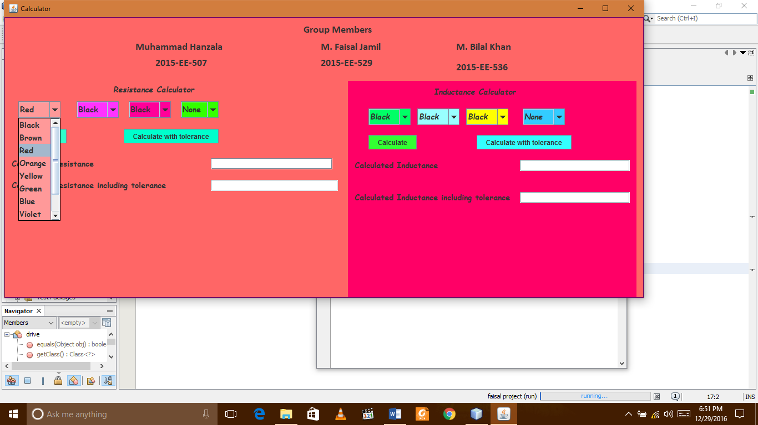

**Step-II**

Similar select the 2nd color of resistor 2nd color give 2nd value of resistance as show below.

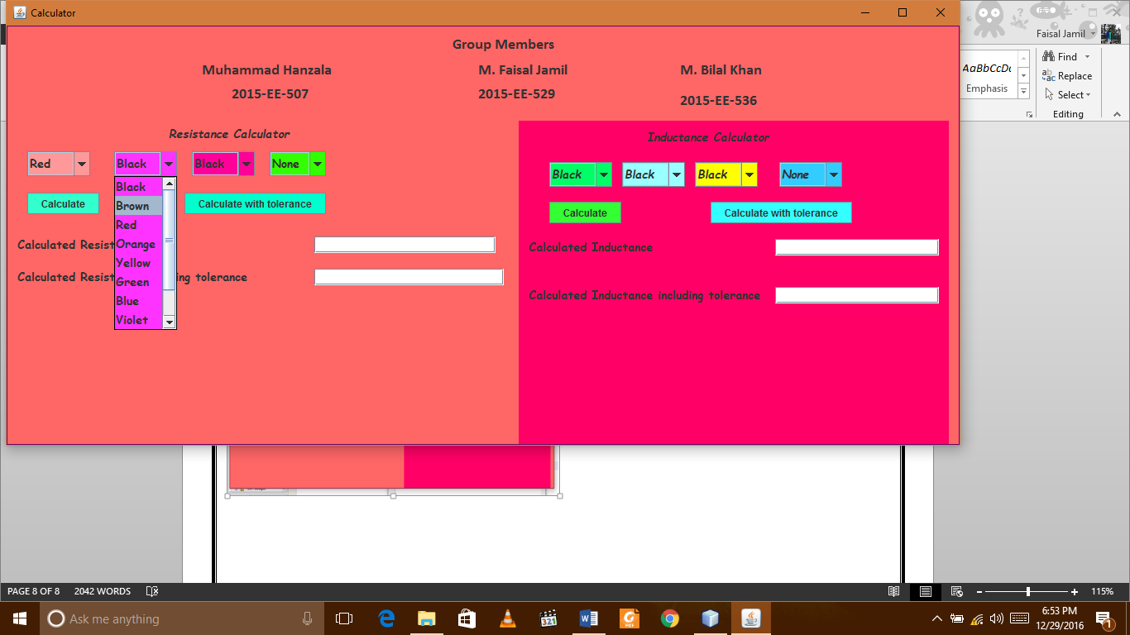

**Step-III**

Now select the color three from band-3. This color give multiple of zero which color has select according to their value.

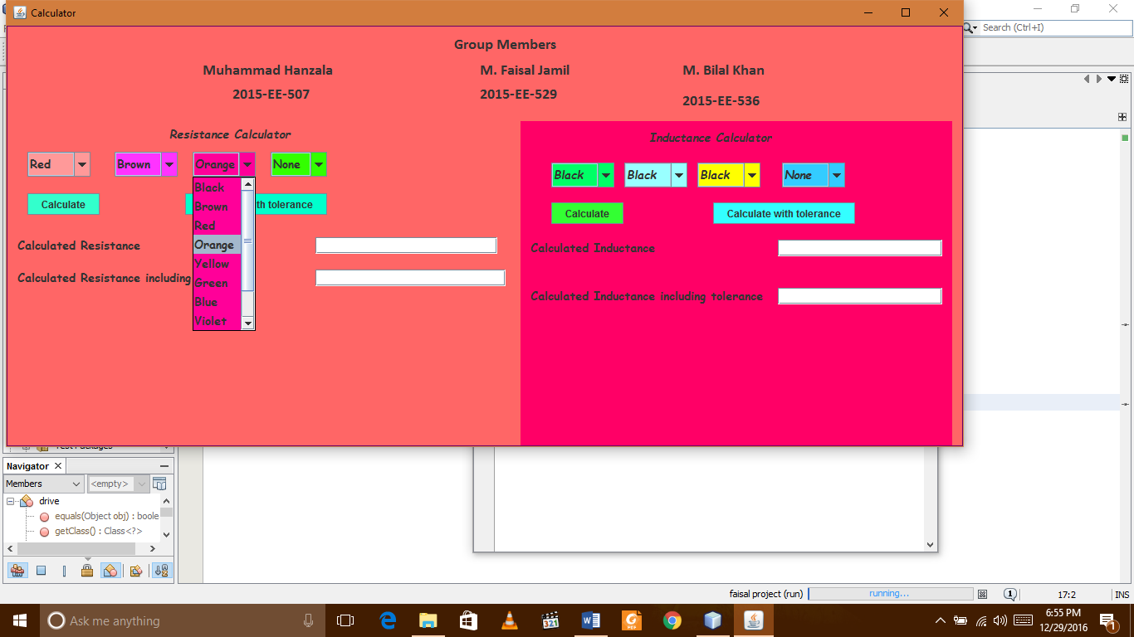

**SStep-IV**

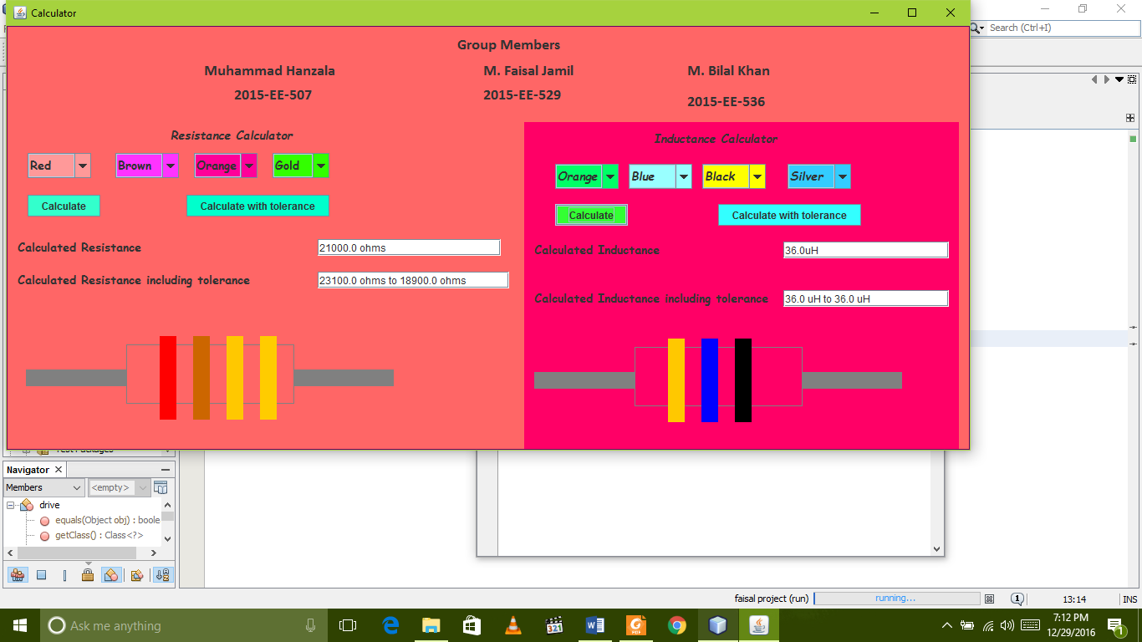After select four color from band four press calculate button to calculate the value with or without tolerance according to your requirement. Select color show below checks this if this matches with your resistor or not if not then selects accurate color.